Activity Name: Skipping

Time : 1 minute

- Challenge for each class (How many skips in 1minute): see below for your class challenge

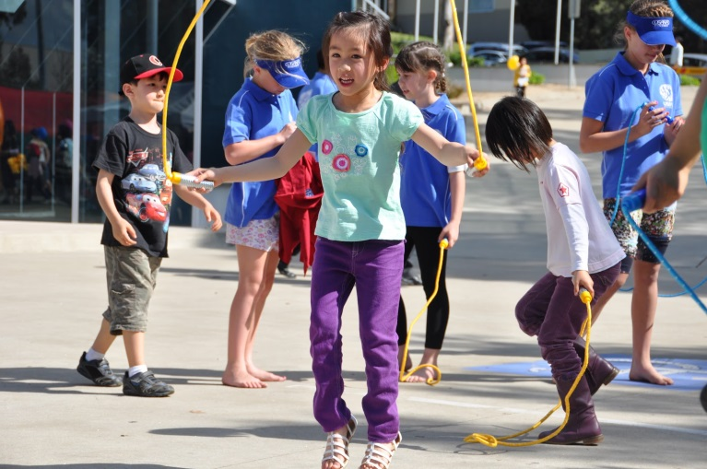
- Junior Infants – 2nd class: Hop the snake (2 people hold one end of the rope each and wave it back and forth on the ground. Jump with both feet from one side of the rope to the other.)
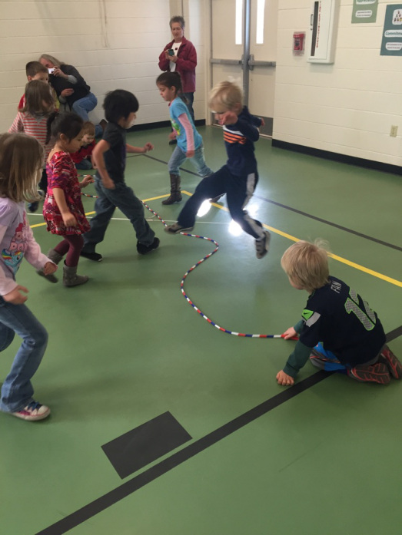
- 3rd + 4th classes: 2 feet to 2 feet jump (how many in 1 minute)
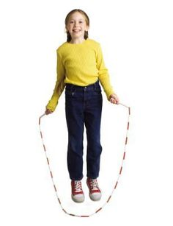
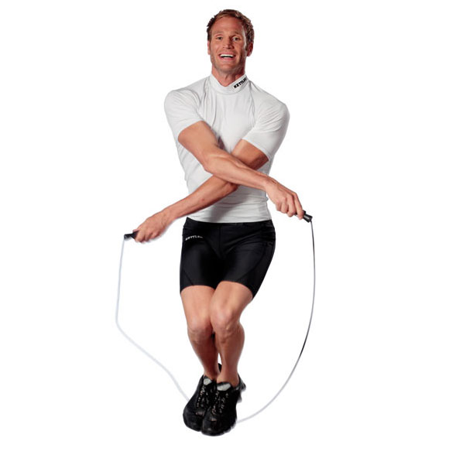
- 5th + 6th = Criss cross (Bring the rope up above your head as you would for the basic step. Cross your arms at the elbows as you bring the rope back down to the elbows. Jump and repeat.)

